Q1

TITLE Add and Subtract (AddSub.asm)

INCLUDE Irvine32.inc

.data

val1 SWORD ?

val2 SBYTE -10

.code

main PROC

MOV ax,val1

MOV bl,val2

call DumpRegs

exit

main ENDP

END main

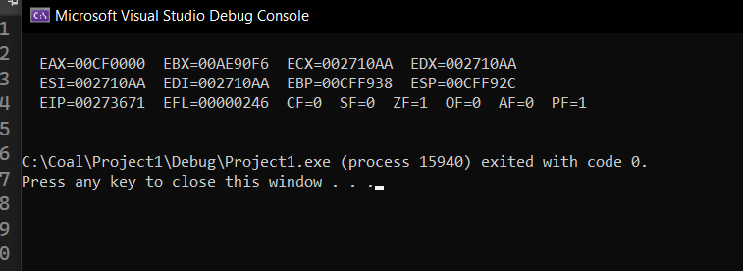

Q2

INCLUDE Irvine32.inc

.data

val3 SDWORD -2147483648

.code

main PROC

MOV eax,val3

call DumpRegs

exit

main ENDP

END main

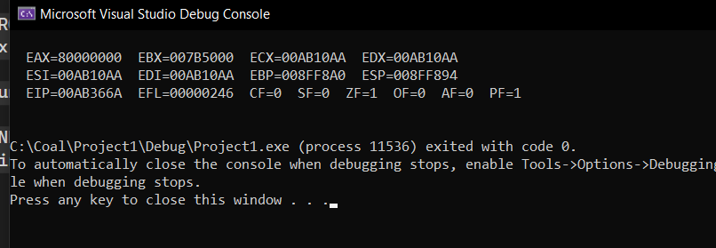

Q3

INCLUDE Irvine32.inc

.data

color BYTE "BLACK",0

varA WORD 12

varB WORD 2

varC WORD 13

varD WORD 8

varE word 14

.code

main PROC

MOV AX,varA

MOV BX,varB

MOV CX,varC

MOV DX,varD

call DumpRegs

exit

main ENDP

END main

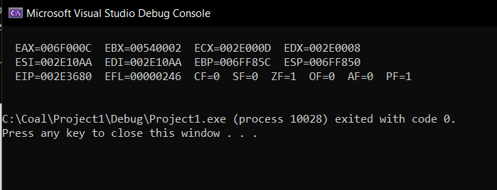

Q4

INCLUDE Irvine32.inc

.code

main PROC

; ebx = {(a+b) - (a-b) + c } + d

; a = 11h, b = 10h, c = 30h, d = 40h

mov ebx, 11h

add ebx, 10h

mov eax, 11h

sub eax, 10h

sub ebx, eax

add ebx, 30h

add ebx, 40h

call DumpRegs

exit

main ENDP

END main

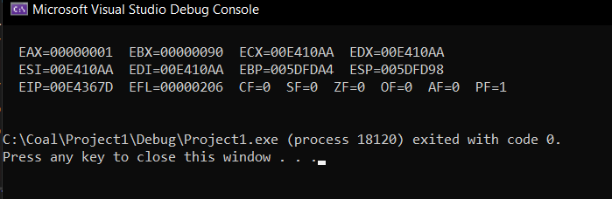

Q5

INCLUDE Irvine32.inc

.data

.data

a byte 10001001b

b byte 10000000b

c byte 11000000b

d byte 11110000b

.code

main PROC

mov AL,a

mov BL,b

movCL,c

mov DL,d

add AL, BL

sub AL, BL

sub AL, BL

add AL, CL

add AL, DL

mov ebx, eax

mov eax, ebx

call

exit

main ENDP

END main

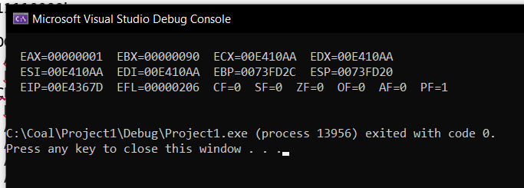

Q6

INCLUDE Irvine32.inc

.data

wArray word 8h, 16h, 32h

.code

main PROC

call DumpRegs

exit

main ENDP

END main

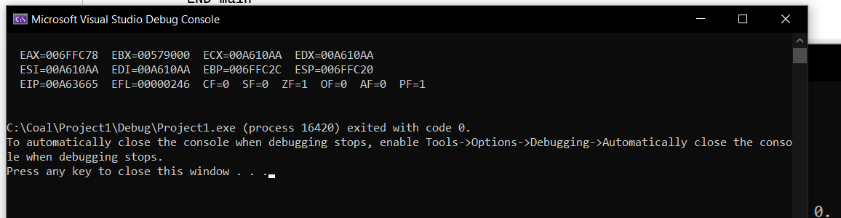

Q7

INCLUDE Irvine32.inc

.data

dArray dword 50 DUP (?)

.code

main PROC

call DumpRegs

exit

main ENDP

END main

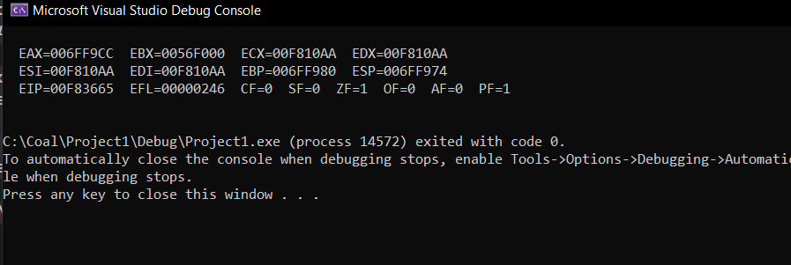

Q8

INCLUDE Irvine32.inc

.data

string BYTE 'TEST',0

repString BYTE 500 DUP ('T','E','S','T')

.code

main PROC

call DumpRegs

exit

main ENDP

END main

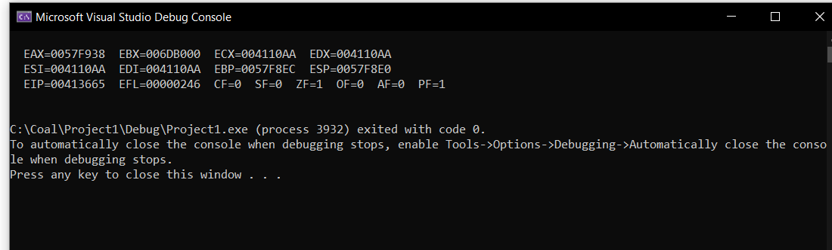

Q9

INCLUDE Irvine32.inc

.data

bArray byte 20 DUP (0)

.code

main PROC

call DumpRegs

exit

main ENDP

END main

